Hack@Speed Christmas Hack Preparation

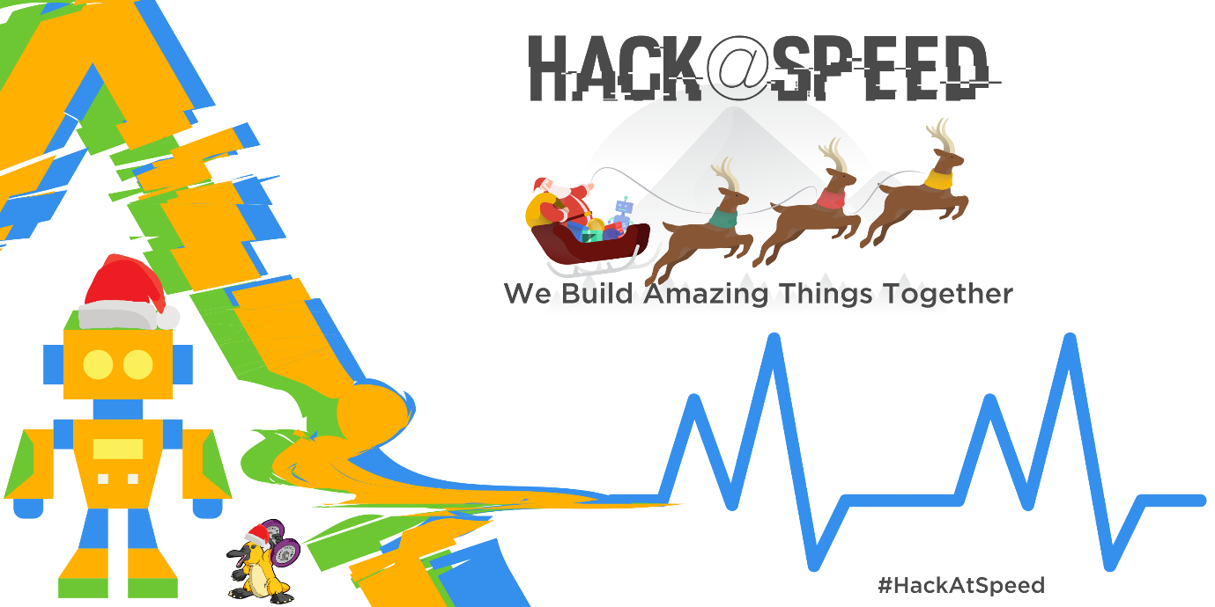

Author: Chris Huntingford

Email: Chris.Huntingford@Microsoft.com

Contents

Prerequisites 3

Introduction 4

The Usecase 5

Background 5

Requirement 6

POWER STATEMENT : 7

The Solution 8

Statement 1 : ANALYSE 8

Statement 2: ACT 8

Statement 3: AUTOMATE 8

Statement 4: ASSIST 9

ANALYSE, ACT, AUTOMATE, ASSIST 9

Core Solution Components 11

The Masterclass Labs Overview 12

Preparation Wrapup 13

# Prerequisites

To complete this workshop, you will need to do the following:

1. Create a trial environment if you do not already have one (Normally when this is run with partners, trials are provided). Instructions can be found [HERE](https://www.youtube.com/watch?v=lfGtjcxeKj4).
2. Access to an Office 365 Environment through the URL : <Portal.office.com>
3. Access to a Power Apps Maker Experience Environment through the URL : <Make.PowerApps.com>
4. Download the “SleighSightings.CSV” File from the described location or from the [GitHub Repository](https://github.com/ChrisHuntingford/HackAtSpeedMain/tree/master/Hackpacks/Christmas%20Hack/Data).
5. Download the latest version of Microsoft Power BI Desktop From [HERE](https://www.microsoft.com/en-us/download/details.aspx?id=58494) or simply follow [this instructional video](https://www.youtube.com/watch?v=JTs2EBGmTBE).

# Introduction

Welcome to the Hack@Speed Masterclass / Hackathon. This walk through is designed to take you through various core areas of the Power Platform in order to help you understand how it all fits together in a very short amount of time. The document contains detailed instructions and Multiple Screen shots that will help you run through the process of becoming a proud Power Platform Maker.

This specific Hack@Speed masterclass focuses on a simple and fun Christmas use case, which will require a technical solution to be implemented that will enable and promote process efficiency and ease of use within a specified organisation. Lets get results FAST!

# The Usecase

## Background

“Sleigh What” are a trusted organisation contracted to help Santa and the team at the north pole manage customer engagement. In particular Santas team need to keep on top of Sleigh Sightings around the world to make sure there are no delays in Christmas present delivery. Every single sleigh sighting sets Santa back a number of minutes due to various reasons such as airspace interference, signal interference and other risks and rissues.

When a sighting is made it can either be logged through the call center or directly in person with a representative from “Sleigh What”.

“Sleigh What” are in the market for a partner to help them out….. Are you up for the job?

## Requirement

“Sleigh What” are storing their data in spread sheets and have no way of tracking all of the urgent sightings that are logged.

Sightings data is sensitive and regulated by the elves. It’s important to make sure that all sightings are tracked in a centralised location and can be taken through a sighting process to completion in a regulated way.

Elves in black need to be notified of all sightings as soon as they take place.

The sightings need to be shared with the elves in black via a report so that they can understand where the sightings are coming from. The elves in black will leverage a mobile app when they visit the specific parties and will use memory erasing magic to clear all knowledge of the sleigh sighting.

## POWER STATEMENT :

**In this hackathon we will be exploring exactly how to build this and actually replicate parts of the solution so that you can gain some hands-on experience in leveraging the Power Platform.**

# The Solution

In order to understand the tools that will need to be leveraged within the use case, the basic process & requirement needs to be reviewed. Take a look at the statement below:

We can very easily, based on the wording, start to understand the types of tools that would be leveraged within the Power platform to build a mini replica of this solution. Let’s break the statement down:

## Statement 1 : ANALYSE

*“The sightings need to be shared with the elves in black via a report so that they can understand where the sightings are coming from.”*

This statement tells us that users need to **ANALYSE** and understand information in order to make a decision.

## Statement 2: ACT

*“…and can be taken through a sighting process to completion in a regulated way “*

*“The elves in black will leverage a mobile app when they visit the specific parties and will use memory erasing magic to clear all knowledge of the sleigh sighting. “*

This statement tells us that a mobile worker will need access to this information in order to **ACT** and undertake various tasks and share information with other people in the organisation.

## Statement 3: AUTOMATE

*“Elves in black need to be notified of all sightings as soon as they take place.”*

This statement tells us that we need to **AUTOMATICALLY** provide information and updates to various members of the team to make sure that the task at hand is completed in a full process driven circle.

## Statement 4: DATA

*“Sightings data is sensitive and regulated by the elves. It’s important to make sure that all sightings are tracked in a centralised location.”*

This statement tells us that the data tracked when capturing sleigh sightings needs to be stored in a secure location with proper data security and auditing. Microsoft Dataverse is the selected location for this data.

## ANALYSE, ACT, AUTOMATE, DATA

When breaking these requirements down into various technical layers its evident that each one of these focuses on at least one core area of the Power Platform.

When breaking this use case into a typical solution design diagram, you can see that the various digital building bricks of the Power Platform fit together cohesively and will work together.

# Core Solution Components

The core focus areas of this course will be as follows:

1. **Power BI (ANALYSE):** To gain full insights and analytics on the relevant Sleigh sighting data, enabling multiple resources with the information they need to effectively undertake their daily tasks.
2. **Power Apps (ACT):** The enable the elves in black the ability to interact with information as and when required as well as fulfil certain tasks that are relevant to their role.
3. **Power Automate Flow (AUTOMATE):** This will provide the automation layer, removing multiple manual interactions from the process mentioned above.
4. **Dataverse (DATA):** Will act as the core relational Data Storage mechanism to hold and manage the sighting data.

# The Hackathon Labs Overview

The labs within the Hack@Speed follow a story and it is suggested that they are done in order. As you progress through the hack solution build you will discover reliance’s between the different modules, exposing just how interconnected each of the Microsoft Power Platform components really are.

|  |  |  |
| --- | --- | --- |
| **Lab Title** | **Technology** | **Dependencies** |
| **Lab 1:** Dataverse & Dataflows | Dataverse | Lab 1 |
| **Lab 2:** Forms, Views Charts | Dataverse | Lab 1 |
| **Lab 3:** Business Process Flow, Model Apps & Dashboards | Flow & PowerApps (Model-Driven Apps) | Lab 1 & Lab 2 |
| **Lab 4:** Microsoft Flow | Power Automate Flow | Lab 1 |
| **Lab 5:** Canvas Apps | Power Apps (Canvas Apps) | Lab 1 |
| **Lab 6:** Power BI | Power BI | Lab 1 |
|  |  |  |

# Preparation Wrap-up

During Hack@Speed you should be equipped with the basics of the Power Platform to enjoy a successful start to your power Platform journey. Do not feel constrained by what is just in the Hack@Speed documentation, feel free to explore and learn about the rest of the amazing functionality within the Power Platform. This will come with hands on experience and practical knowledge. Work together to build something AMAZING!

#BuildCoolStuff

All the best for the challenges.

Chris

